How to Create Hyperlink On SB/XA Screen That Opens In the Default Web Browser

This tech note details how to create a hyperlink within an SB/XA screen to open in the systems default browser. The theme is included at the bottom of this document.
Instructions:
- Download and save the attached theme, 'HyperLinkTheme', into the 'xxTHEMES' directory within the SB Account where the hyperlink is to be created.
  - The 'xxTHEMES' directory is prefixed with 'xx', on the system this will be the System ID for the account. For example within the SBDEMO account CH system this directory is called 'CHTHEMES'

- Once in place in the xxTHEMES directory, add it to the account via /THEME.DEFN
  - 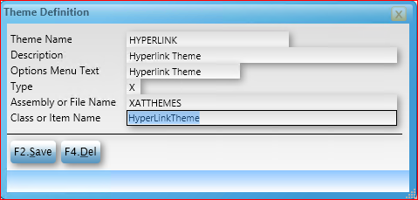

- Once added as a theme to the account, add the theme to 'Available Themes' in /HK.CONTROL -> XUI
  - 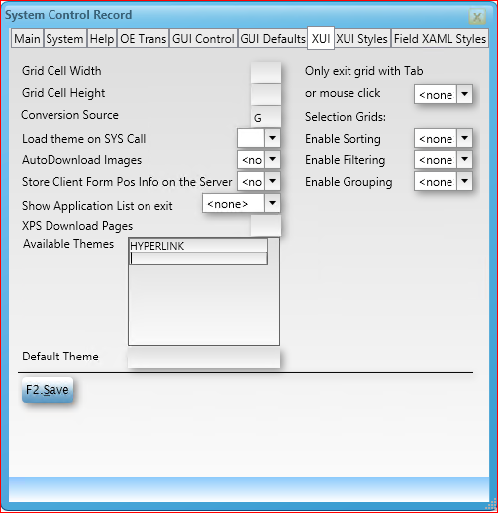

- After placing the theme in /HK.CONTROL, log off and back in to the rich client for the change to take effect.

- Compile the theme using /TH.C
  - 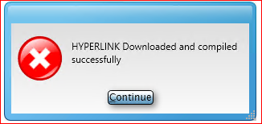

- Install the theme using /TH.I
  - 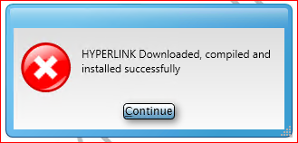
- If installed correctly, the XUI rich client background should read the name of the theme: "HYPERLINK"
  - This is controlled by the same theme and can be removed, it is controlled by the following line in the theme:
  - <Style x:Key="SBPlusStyle" BasedOn="{StaticResource DefaultSBPlusStyle}" TargetType="{x:Type sbc:SBPlus}">
<Setter Property="ShowThemeName" Value="True"/>
</Style>
  - If a theme is currently in use, the content of 'HyperLinkTheme' can be added to the currently running theme.
- Create a paragraph process within the account called 'CALL.BROWSER', this paragraph uses the complete URL, which is the data value of a field which is using the hyperlink style, to open the URL in the default browser.
  - /PD.P
  - Process Name: CALL.BROWSER
Description:
Dict File Name:
Paragraph Lines:
LOCAL X
X = '"START" ':@PARAM
CALL TU.EXECUTE.SHELL(X, "P")

With the previous steps completed the account is now set up to create hyperlinks on screens. The next section will go through adding a hyperlink to an input screen.

- Within the file being used to create the screen create a new dictionary item for the URL, this field will contain the complete URL to be turned into a hyperlink:
  - 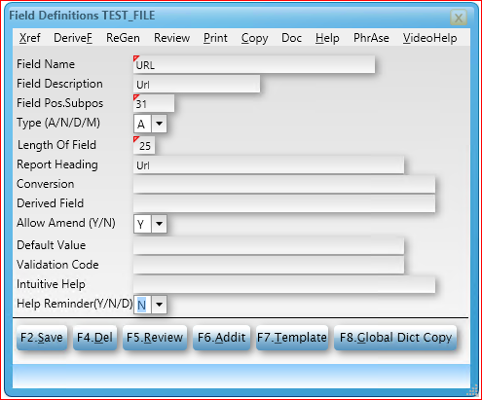
- In the case that this field is being added to an already existing file, a maintenance screen will be required to add a URL to the record. Once the theme is applied to the field, it is no longer accessible on the screen to make changes. A simple screen with only the record ID and URL field is enough to maintain the URL:
  - 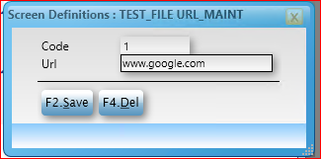

- Now that the record contains a URL, a screen can be modified or created to show this URL as a hyperlink.

- Once the URL field is on a screen, add the line "hyperlinkCallProcessKey" to the 'XAML Style' field for the URL:
  - Open the screen in /SD
  - Click on the URL Field and press F5 for details on the field:
  - 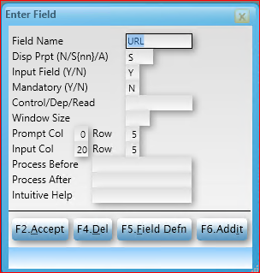
  - Press F6 - Addit for the XAML style options:
  - 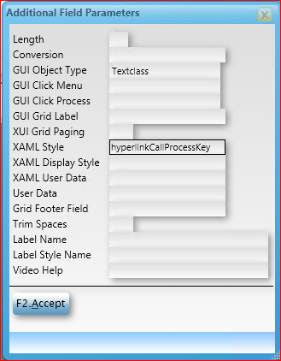
  - Add the line "hyperlinkCallProcessKey" to the 'XAML Style' field and save the field. The "hyperlinkCallProcessKey" is defined in the theme that was added to the system and is what turns the text into a hyperlink.
  - Save the screen.

- With the XAML style applied to the field, when opening the screen and record we see the following:
  - 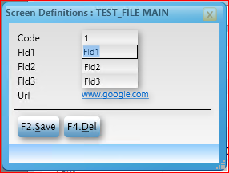
  - www.google.com is now a hyperlink on the screen.

- When the new hyperlink field is clicked the URL will open in the client machines default web browser.

SBXA HyperLinkTheme:
<ResourceDictionary
xmlns="http://schemas.microsoft.com/winfx/2006/xaml/presentation"
xmlns:x="http://schemas.microsoft.com/winfx/2006/xaml"
xmlns:sbc="http://schemas.sbxa.com/WPFControls"
>

<Style x:Key="SBPlusStyle" BasedOn="{StaticResource DefaultSBPlusStyle}" TargetType="{x:Type sbc:SBPlus}">
<Setter Property="ShowThemeName" Value="True"/>
</Style>

<!-- call SB process from hyperlink -->

<Style x:Key="hyperlinkCallProcessStyle" BasedOn="{StaticResource DefaultSBTextBoxStyle}" TargetType="{x:Type sbc:SBTextBox}">
<Setter Property="sbc:SBControl.ShouldSendSBCommands" Value="False" />
<Setter Property="Template">
<Setter.Value>
<ControlTemplate TargetType="{x:Type TextBoxBase}">
<Border>
<TextBlock>
<Hyperlink Command="sbc:SBCommands.ExecuteSBPlusProcessCommand" CommandParameter="{Binding Path=Text, RelativeSource={RelativeSource TemplatedParent}, Converter={StaticResource SBProcessNameConverter}, ConverterParameter=CALL.BROWSER}" CommandTarget="{x:Static sbc:SBPlus.Current}">
<sbc:SBRun BoundText="{Binding Path=Text, RelativeSource={RelativeSource TemplatedParent}}"/>
</Hyperlink>
</TextBlock>
</Border>
</ControlTemplate>
</Setter.Value>
</Setter>
</Style>

<Style x:Key="hyperlinkCallProcessKey" TargetType="{x:Type sbc:SBField}">
<Setter Property="SBControlStyle" Value="{DynamicResource hyperlinkCallProcessStyle}"/>
<Setter Property="FieldFocusControlStyle" Value="{DynamicResource hyperlinkCallProcessStyle}"/>
</Style>

</ResourceDictionary>

