Installation of Sentinel License Manager Uniface Sentinel RMS 240111:

Download the installation software from the website https://my.rocketsoftware.com/ Via the Downloads menu, you can choose the Uniface product. You can then choose the latest version of the Uniface Sentinel RMS (currently Uniface Sentinel RMS 240111 as of 2024-01-17). Here the correct installation file is chosen (currently UnifaceRMS100-240111-w32.exe). You may need to increase the value for Rows Displayed to see the versions for Windows.
The installation software is located in the folder : E:\Installation software
The used installation directory is : E:\Programs\Sentinel

Launch UnifaceRMS100-240111-w32.exe in the installer directory | UnifaceRMS100-240111-w32.exe
Every time a User Account Control pop-up pops up:
choose Yes
The installation starts with extracting the installation software. Select OK | 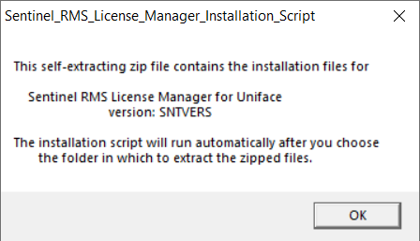
Use the default values and choose Unzip | 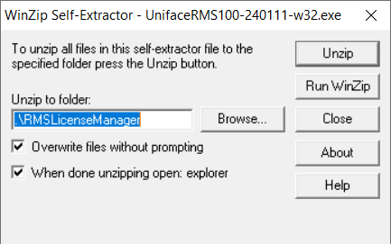
The installation software will be extracted to the said directory. | 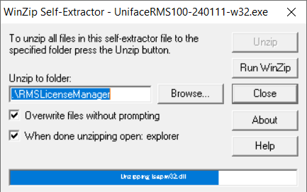
The installation software has been extracted. Select OK | 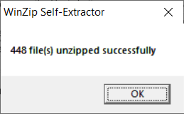
A User Account Control pop-up appears:
choose Yes
The installation script starts. Press the enter key to continue. | 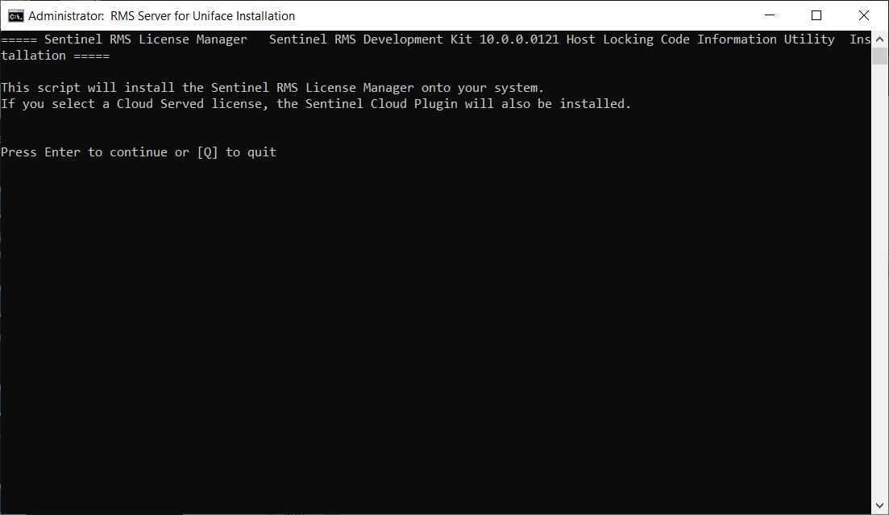
The RMS License Agreement in "RMS-EULA.txt" can be read, if desired.  Choose Y to accept the license terms. | 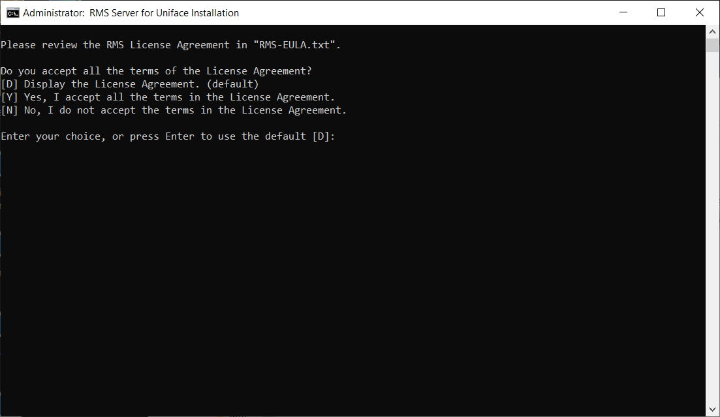
Fill in the destination directory (example : E:\Programs\Sentinel). | 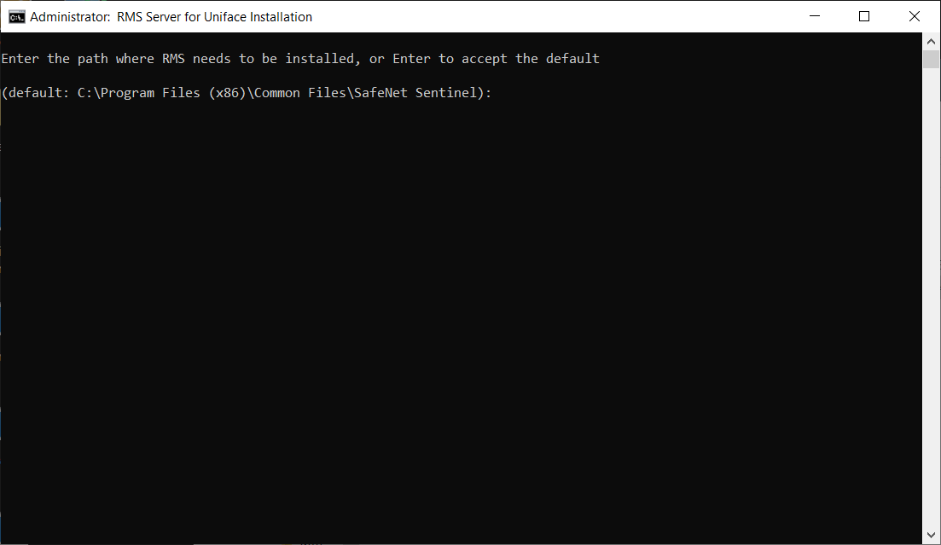
Choose the type of license.  Choose for 3 (Install RMS and I will configure the license later) | 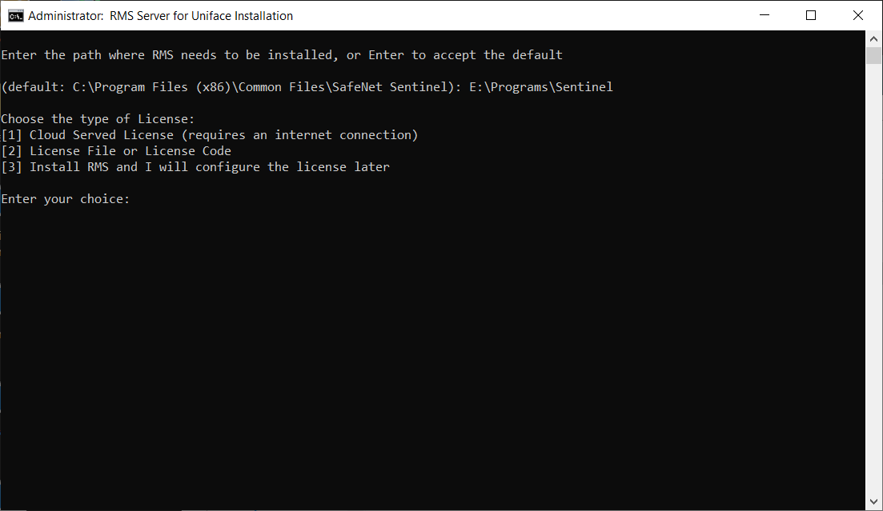
The installation of the software takes place.  Press de enter key to continue. | 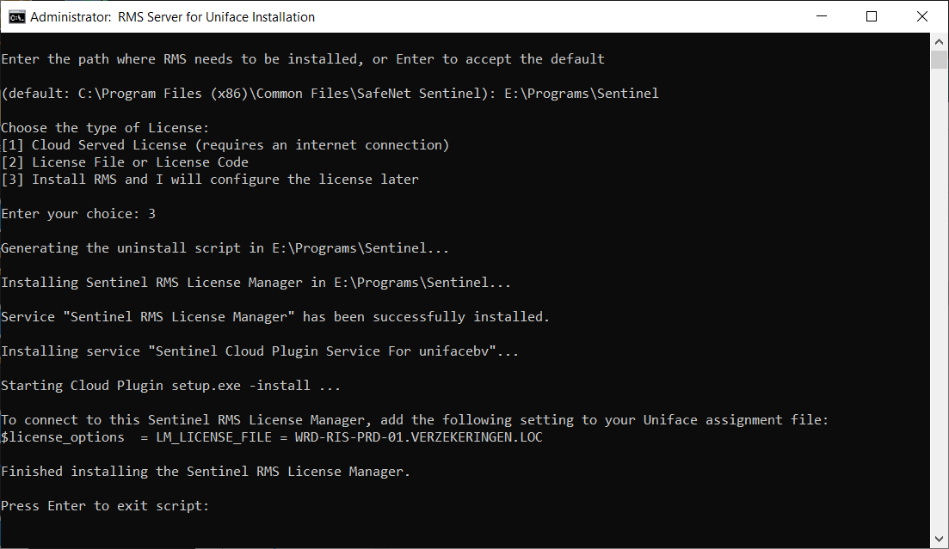
The installation is complete.

Two services are installed:
- Sentinel RMS License Manager
- Sentinel Cloud Plugin Service For unifacebv

