Environment
Workspace Path: /var/tmp/vscode
Settings path within “Path”: .vscode/settings.json
Example program: /usr/uv/APP.PROGS/FMT.BASIC.B
VS Code launched by non-root user
VS Code command line: code /var/tmp/vscode
VS Code key input to open prog: <ctrl>p FMT.BASIC.B (select the APP.PROGS version)

Folder Setup
mkdir -p /var/tmp/vscode
cd /var/tmp/vscode
cp -r /usr/uv/APP.PROGS .

Then the .vscode directory was created and populated with the settings.json file provided by Charles Han

Setting supplied by Charles Han
Additions by me are bold italics
{
"[rocket-mvbasic]": {
"editor.codeLens": false
},
"files.associations": {
"**/APP.PROGS/*": "rocket-mvbasic",
"**/BP/*": "rocket-mvbasic",
"**/PBP/*": "rocket-mvbasic",
"**/.rmv/config/*.json": "jsonc"
},
"files.exclude": {
"**/.git": true,
"**/.svn": true,
"**/.hg": true,
"**/CVS": true,
"**/.DS_Store": true,
"**/Thumbs.db": true,
"**/.rmv/catalog/**": true,
"*/_*": false
},
"breadcrumbs.enabled": true,
"breadcrumbs.showFunctions": true,
"breadcrumbs.showVariables": true
}

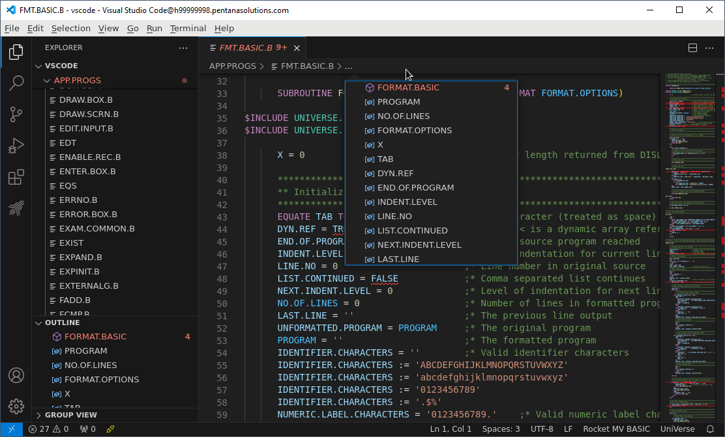
So we see function names, internal subroutine names and variables in both the outline and the breadcrumbs trail.

With Rocket Code lens enabled
Changes are in bold
{
"[rocket-mvbasic]": {
"editor.codeLens": true
},
"files.associations": {
"**/APP.PROGS/*": "rocket-mvbasic",
"**/BP/*": "rocket-mvbasic",
"**/PBP/*": "rocket-mvbasic",
"**/.rmv/config/*.json": "jsonc"
},
"files.exclude": {
"**/.git": true,
"**/.svn": true,
"**/.hg": true,
"**/CVS": true,
"**/.DS_Store": true,
"**/Thumbs.db": true,
"**/.rmv/catalog/**": true,
"*/_*": false
},
"breadcrumbs.enabled": true,
"breadcrumbs.showFunctions": true,
"breadcrumbs.showVariables": true
}

The above is how the settings.json file looks from the command line.
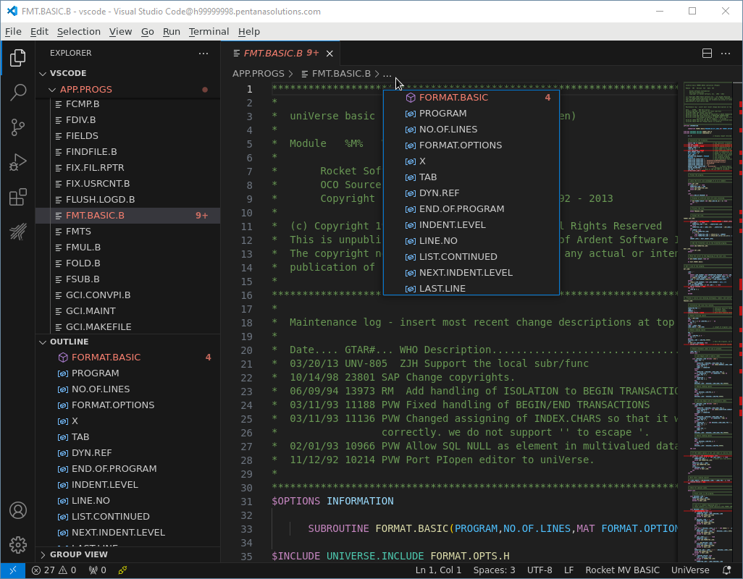
This looks no different to the default setup
The settings dialog shows that Code Lens is disabled for the Rocket MV BASIC extension
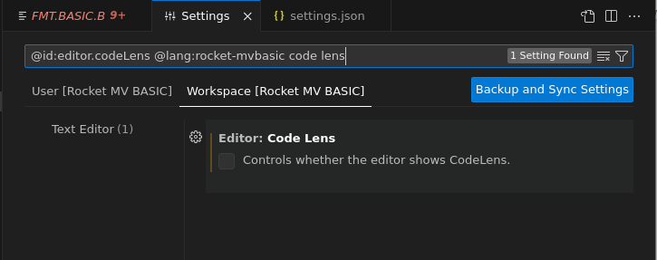
The actual settings.json file that VS Code is working with reflects that
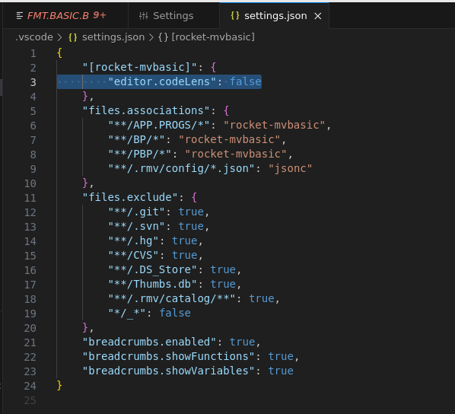
Yet the physical file has the highlighted line set to “true” !

With Code Lens enabled outside of Rocket
Changes to content from the original version are in bold
{
"[rocket-mvbasic]": {
"editor.codeLens": false
},
"files.associations": {
"**/APP.PROGS/*": "rocket-mvbasic",
"**/BP/*": "rocket-mvbasic",
"**/PBP/*": "rocket-mvbasic",
"**/.rmv/config/*.json": "jsonc"
},
"files.exclude": {
"**/.git": true,
"**/.svn": true,
"**/.hg": true,
"**/CVS": true,
"**/.DS_Store": true,
"**/Thumbs.db": true,
"**/.rmv/catalog/**": true,
"*/_*": false
},
"editor.codeLens": true,
"breadcrumbs.enabled": true,
"breadcrumbs.showFunctions": true,
"breadcrumbs.showVariables": true
}

No difference to the default setup
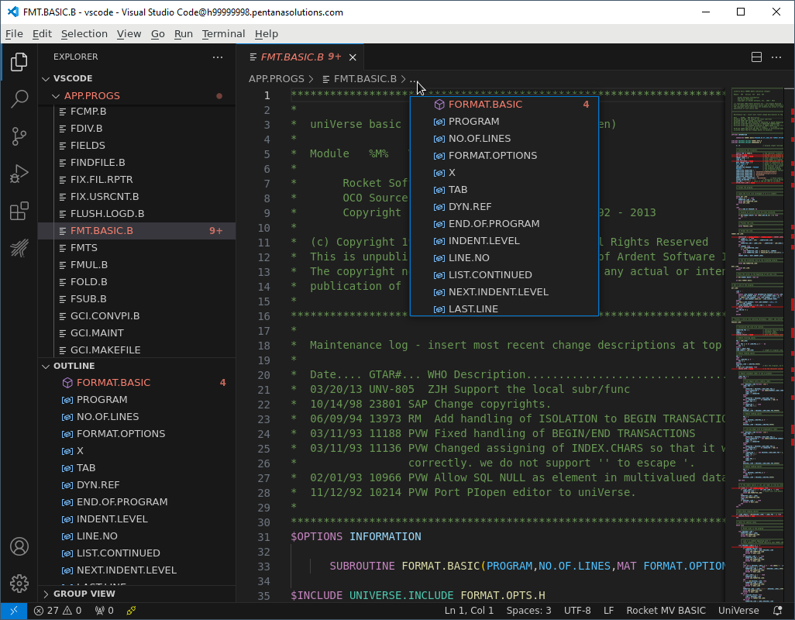

With Code Lens enabled in both
Changes to content from the original version are in bold
{
"[rocket-mvbasic]": {
"editor.codeLens": true
},
"files.associations": {
"**/APP.PROGS/*": "rocket-mvbasic",
"**/BP/*": "rocket-mvbasic",
"**/PBP/*": "rocket-mvbasic",
"**/.rmv/config/*.json": "jsonc"
},
"files.exclude": {
"**/.git": true,
"**/.svn": true,
"**/.hg": true,
"**/CVS": true,
"**/.DS_Store": true,
"**/Thumbs.db": true,
"**/.rmv/catalog/**": true,
"*/_*": false
},
"editor.codeLens": true,
"breadcrumbs.enabled": true,
"breadcrumbs.showFunctions": true,
"breadcrumbs.showVariables": true
}
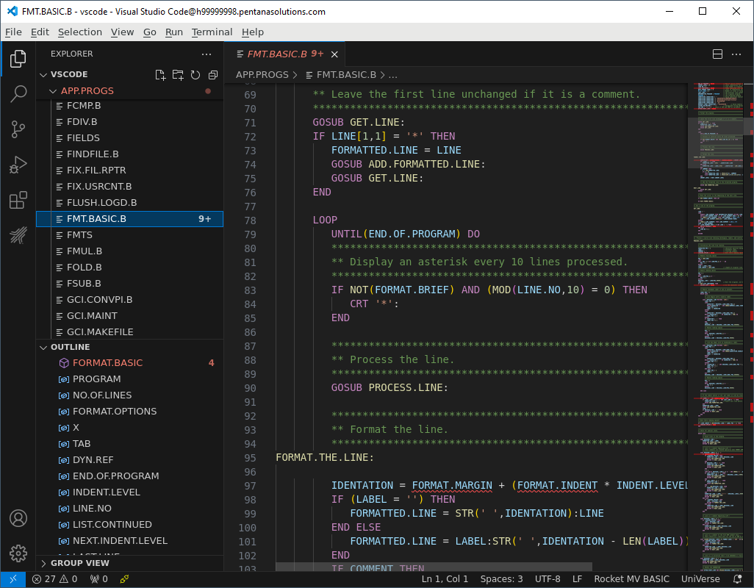
Again, no difference to the default setup.
Again, the settings being used at runtime do not match the settings.json file setup
(exactly like With Code Lens enabled outside of Rocket)
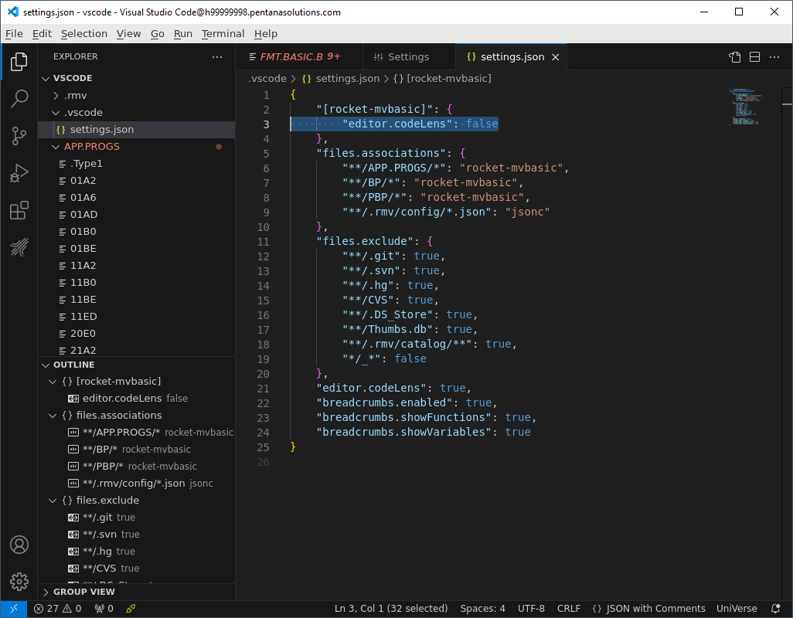

With Code Lens disabled but Rocket Code Lens enabled
Changes to content from the original version are in bold
{
"[rocket-mvbasic]": {
"editor.codeLens": true
},
"files.associations": {
"**/APP.PROGS/*": "rocket-mvbasic",
"**/BP/*": "rocket-mvbasic",
"**/PBP/*": "rocket-mvbasic",
"**/.rmv/config/*.json": "jsonc"
},
"files.exclude": {
"**/.git": true,
"**/.svn": true,
"**/.hg": true,
"**/CVS": true,
"**/.DS_Store": true,
"**/Thumbs.db": true,
"**/.rmv/catalog/**": true,
"*/_*": false
},
"editor.codeLens": false,
"breadcrumbs.enabled": true,
"breadcrumbs.showFunctions": true,
"breadcrumbs.showVariables": true
}

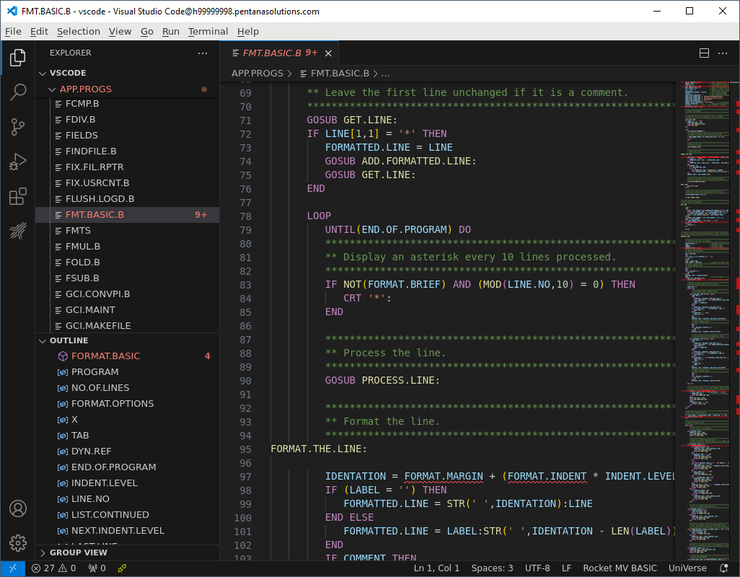
Exactly like the previous 2 tests.
The runtime version of the settings.json is different to the file as stored on the filesystem
