How to Transfer SBXA Group Security Restrictions From One Group to Another

Summary: When adding a new group in SystemBuilder it may be necessary to transfer restrictions from an existing group to the new. In an SB environment it is possible to have multiple group security restrictions in place and adding these manually or via the SB security API can be difficult or time consuming.

Demo:
A process, RESTRICT.COPY, is available in SB. This process allows a user to copy group or account restrictions from one group or account to another.
Run the process /RESTRICT.COPY:
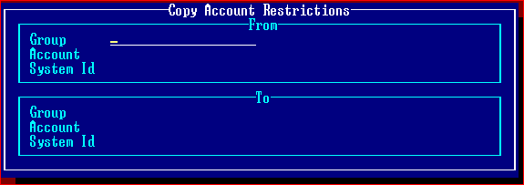
Choose the Group, Account, and System ID to copy from and select the Group, Account, and System ID to copy to.
Example:
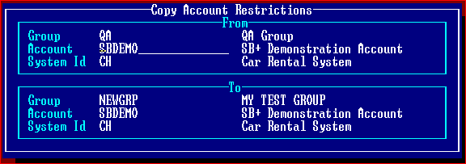
In this example, the restrictions in the QA group are going to be transferred to NEWGRP and apply to the same account and system ID.
QA Group Restrictions:
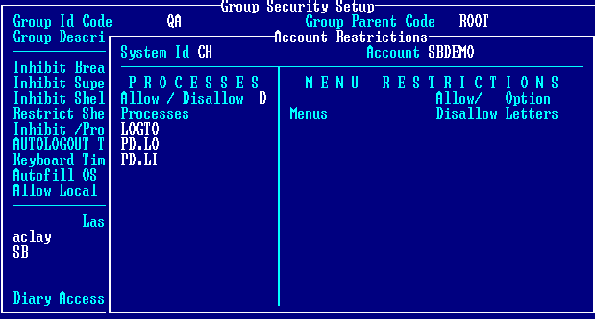
New NEWGRP Group Restrictions:
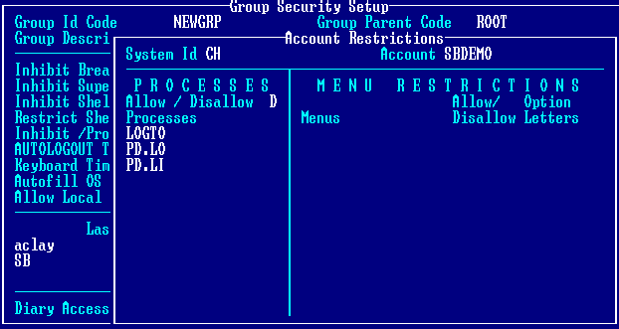
The restrictions in NEWGRP now match those setup in the QA group.

