Environment
Workspace Path: /var/tmp/workspace
Settings path within “Path”: test.code-workspace
Example program: /usr/uv/APP.PROGS/FMT.BASIC.B
VS Code launched by non-root user
VS Code command line: code --file-uri /var/tmp/workspace/test.code-workspace
VS Code key input to open prog: <ctrl>p FMT.BASIC.B (select the APP.PROGS version)

Folder Setup
mkdir -p /var/tmp/vscode
cd /var/tmp/vscode
cp -r /usr/uv/APP.PROGS .
cd ~
mkdir -p /var/tmp/workspace

The “.vscode” subdir of /var/tmp/vscode was removed
Within the “workspace” the following was saves as “test.code-workspace”
{
"folders": [
{
"name": "vscode",
"path": "/var/tmp/vscode"
}
],
"settings": {
"[rocket-mvbasic]": {
"editor.codeLens": false
},
"files.exclude": {
"**/.git": true,
"**/.svn": true,
"**/.hg": true,
"**/CVS": true,
"**/.DS_Store": true,
"**/Thumbs.db": true,
"**/.rmv/catalog/**": true,
"*/_*": false
},
"files.associations": {
"**/.rmv/config/*.json": "jsonc",
"**/APP.PROGS/*": "rocket-mvbasic",
"**/BP/*": "rocket-mvbasic",
"**/PBP/**": "rocket-mvbasic",
"**/XDBP/**": "rocket-mvbasic"
},
"editor.codeLens": true,
"breadcrumbs.enabled": true,
"breadcrumbs.showFunctions": true,
"breadcrumbs.showVariables": true,
},
"extensions": {
"recommendations": [
"rocketsoftware.rocket-mvbasic"
]
}
}

Note that “editor.codeLens” is false for the rocket-mvbasic extension and enabled for the workspace.

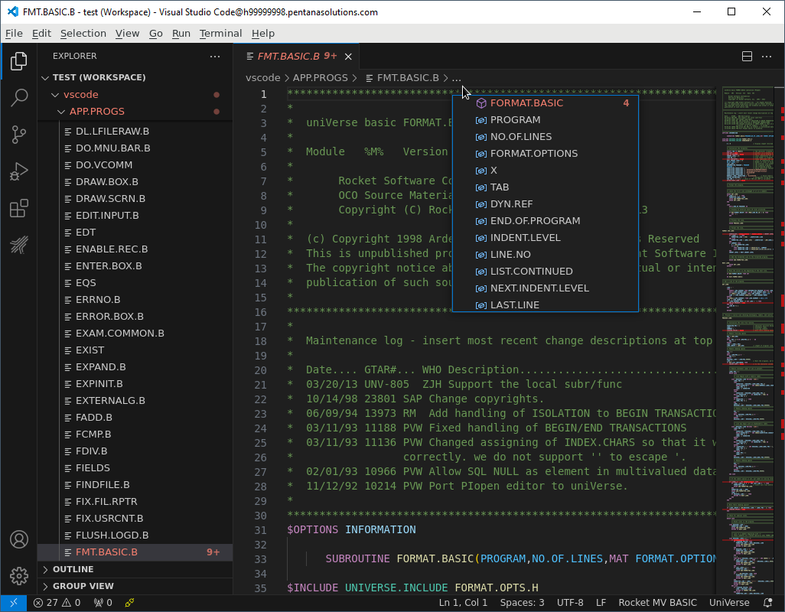
This is as expected

With Rocket Code Lens enabled
The test.code-workspace file was adjusted thusly
"settings": {
"[rocket-mvbasic]": {
"editor.codeLens": true
},
Though the full functionality it not present
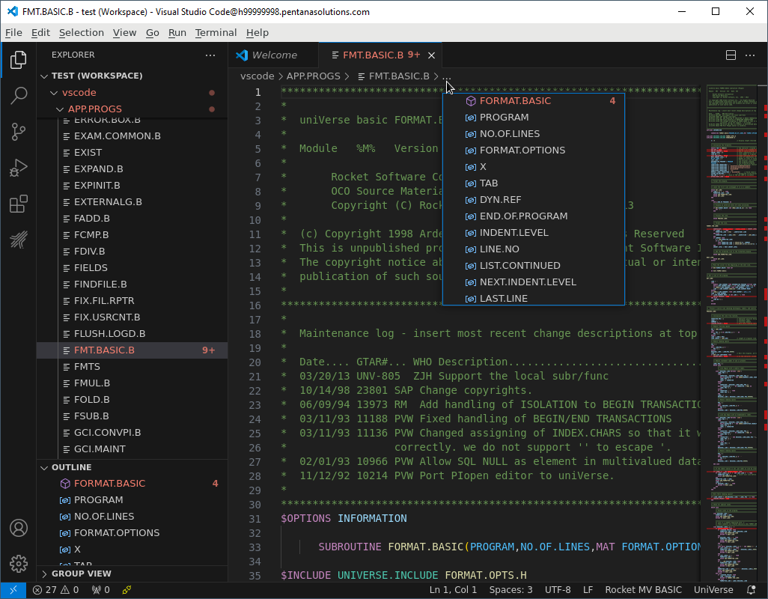
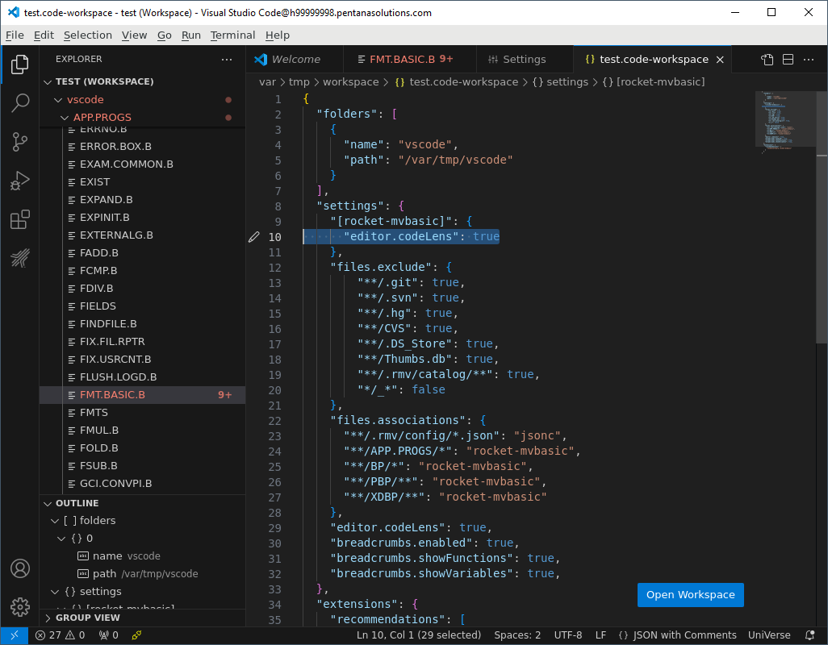
This time, the runtime setting matches the file as saved.

