Environment
Path: /usr/uv
Settings path within “Path”: .vscode/settings.json
Example program: /usr/uv/APP.PROGS/FMT.BASIC.B
VS Code launched by non-root user
VS Code command line: code /usr/uv
VS Code key input to open prog: <ctrl>p FMT.BASIC.B (select the APP.PROGS version)

Setting supplied by Charles Han
Additions by me are bold italics
{
"[rocket-mvbasic]": {
"editor.codeLens": false
},
"files.associations": {
"**/APP.PROGS/*": "rocket-mvbasic",
"**/BP/*": "rocket-mvbasic",
"**/PBP/*": "rocket-mvbasic",
"**/.rmv/config/*.json": "jsonc"
},
"files.exclude": {
"**/.git": true,
"**/.svn": true,
"**/.hg": true,
"**/CVS": true,
"**/.DS_Store": true,
"**/Thumbs.db": true,
"**/.rmv/catalog/**": true,
"*/_*": false
},
"breadcrumbs.enabled": true,
"breadcrumbs.showFunctions": true,
"breadcrumbs.showVariables": true
}

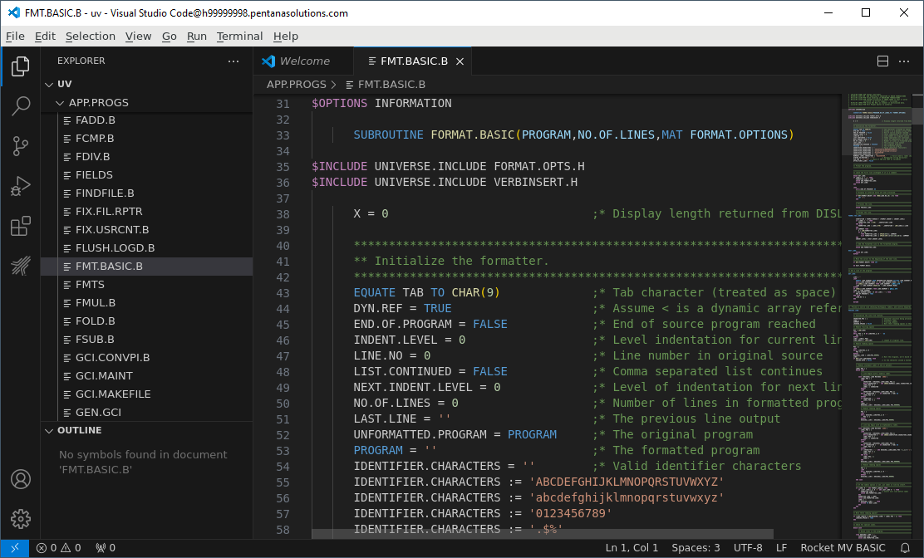

With Rocket CodeLens enabled
Changes to content from the original version are in bold
{
"[rocket-mvbasic]": {
"editor.codeLens": true
},
"files.associations": {
"**/APP.PROGS/*": "rocket-mvbasic",
"**/BP/*": "rocket-mvbasic",
"**/PBP/*": "rocket-mvbasic",
"**/.rmv/config/*.json": "jsonc"
},
"files.exclude": {
"**/.git": true,
"**/.svn": true,
"**/.hg": true,
"**/CVS": true,
"**/.DS_Store": true,
"**/Thumbs.db": true,
"**/.rmv/catalog/**": true,
"*/_*": false
},
"breadcrumbs.enabled": true,
"breadcrumbs.showFunctions": true,
"breadcrumbs.showVariables": true
}

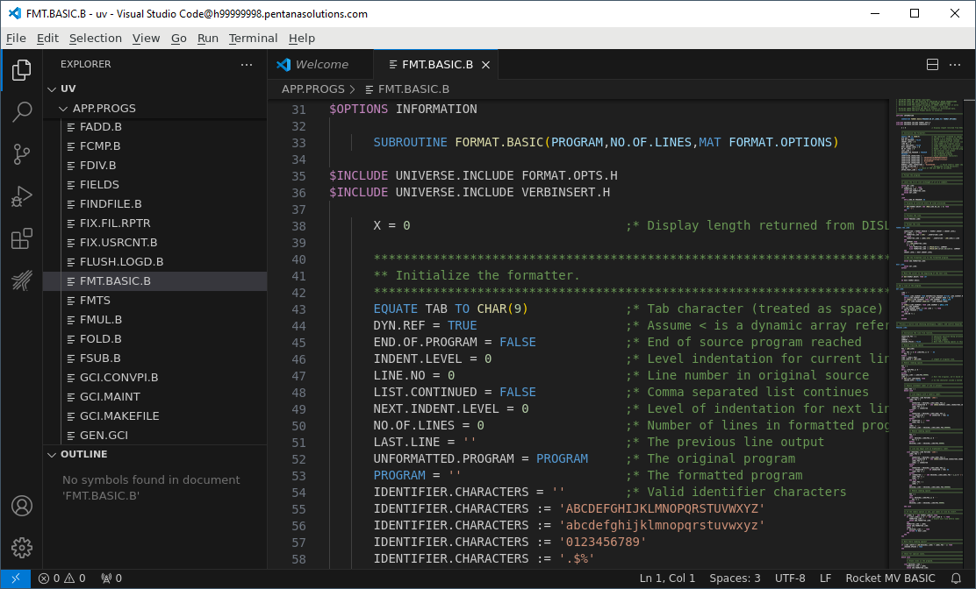

With Code Lens enabled outside of Rocket
Changes to content from the original version are in bold
{
"[rocket-mvbasic]": {
"editor.codeLens": false
},
"files.associations": {
"**/APP.PROGS/*": "rocket-mvbasic",
"**/BP/*": "rocket-mvbasic",
"**/PBP/*": "rocket-mvbasic",
"**/.rmv/config/*.json": "jsonc"
},
"files.exclude": {
"**/.git": true,
"**/.svn": true,
"**/.hg": true,
"**/CVS": true,
"**/.DS_Store": true,
"**/Thumbs.db": true,
"**/.rmv/catalog/**": true,
"*/_*": false
},
"editor.codeLens": true,
"breadcrumbs.enabled": true,
"breadcrumbs.showFunctions": true,
"breadcrumbs.showVariables": true
}

With Code Lens enabled in both
Changes to content from the original version are in bold
{
"[rocket-mvbasic]": {
"editor.codeLens": true
},
"files.associations": {
"**/APP.PROGS/*": "rocket-mvbasic",
"**/BP/*": "rocket-mvbasic",
"**/PBP/*": "rocket-mvbasic",
"**/.rmv/config/*.json": "jsonc"
},
"files.exclude": {
"**/.git": true,
"**/.svn": true,
"**/.hg": true,
"**/CVS": true,
"**/.DS_Store": true,
"**/Thumbs.db": true,
"**/.rmv/catalog/**": true,
"*/_*": false
},
"editor.codeLens": true,
"breadcrumbs.enabled": true,
"breadcrumbs.showFunctions": true,
"breadcrumbs.showVariables": true
}

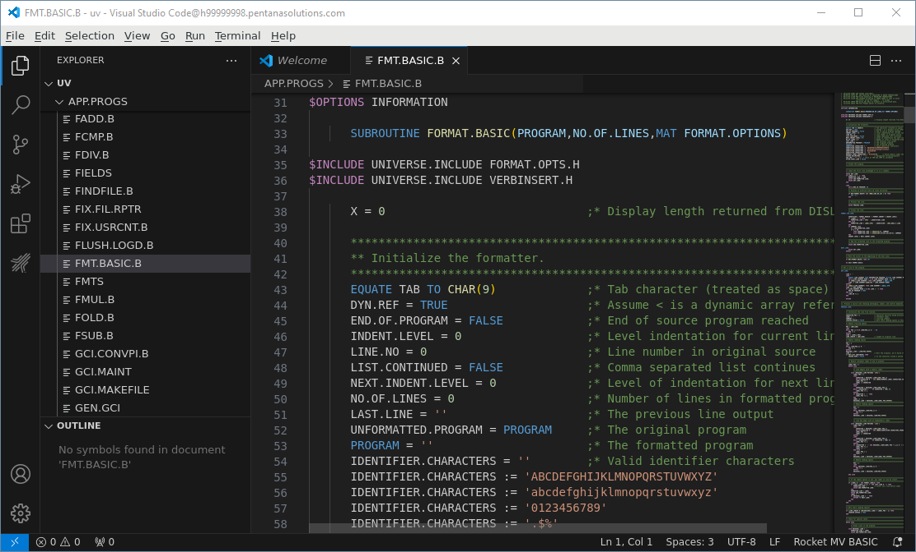

With Code Lens disabled but Rocket Code Lens enabled
Changes to content from the original version are in bold
{
"[rocket-mvbasic]": {
"editor.codeLens": true
},
"files.associations": {
"**/APP.PROGS/*": "rocket-mvbasic",
"**/BP/*": "rocket-mvbasic",
"**/PBP/*": "rocket-mvbasic",
"**/.rmv/config/*.json": "jsonc"
},
"files.exclude": {
"**/.git": true,
"**/.svn": true,
"**/.hg": true,
"**/CVS": true,
"**/.DS_Store": true,
"**/Thumbs.db": true,
"**/.rmv/catalog/**": true,
"*/_*": false
},
"editor.codeLens": false,
"breadcrumbs.enabled": true,
"breadcrumbs.showFunctions": true,
"breadcrumbs.showVariables": true
}

Directly Opening program in VS Code
Command line: code /usr/uv/APP.PROGS/FMT.BASIC.B
Using setup from With Code Lens disabled but Rocket Code Lens enabled
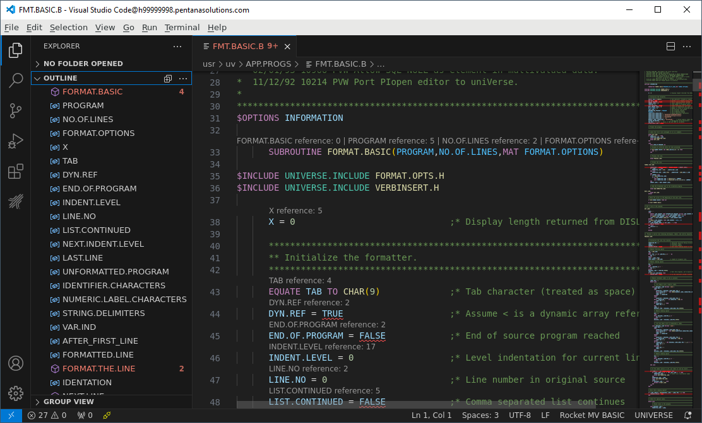
None of the settings in the settings.json file are referenced at all
Pressing <ctrl>, shows that only User settings are active:
